Having Fun With Dwarves

While most articles about having fun with Dwarves probably focus on drinking beer and telling ribald jokes, this one addresses a more serious issue: Dwarves in Warmaster are at a significant disadvantage when it comes to most battlefields. Warmaster is a game about quick action and sweeping army movements. Lightning fast cavalry strikes are the bomb, and anyone who has tried their hand at the Dwarves probably knows that sinking feeling in the pit of their stomach as they look over a wide open battlefield. The solution is not just to make more forests and paint tons of hills. These help but don’t address the core issue.

Let’s dissect the problem a bit further. Some will contend that the Dwarves are flawed because they have no cavalry and no monsters. This is wrong. Sure, not having cavalry is a challenge. They are the most powerful units in the game. However, cavalry is most effective when charging en masse at an opponent. A long line of knights racing across the open field will decimate almost any defense. The Dwarves have the answer to that problem in their cannons which can disrupt the enemy lines while simultaneously ignoring the tough armor of their foes. The problem with this counter-knight strategy is that the Dwarves must focus their firepower on the nearest target, and a clever opposing general will put a sacrificial unit of cheap infantry out in front of their expensive knights.

As to monsters, my experience over the last five years is that monsters add flavor, monsters are fun, and in certain instances throwing in a terror-causing monster can be very effective at turning the tide of a battle. In general, however, monsters are too expensive and too slow to be universally effective. Terror doesn’t help you against the Undead, and try catching a unit of knights with a giant. The exception to this rule is fliers which have many uses in the game. That said, adding monsters to the Dwarven roster is not the answer.

This leads me to the second weakness of the Dwarves and the real problem underlying why they fare so poorly in most situations. They have no expendable troops. The Trollslayers, at 80 points, are a luxury unit compared to a unit of Clan Rats at 25 points. The most effective way to thwart a cavalry charge in the open field is to put a speed bump in the road. The units die, but you get a chance to counter-charge with your cavalry, or in the case of the Dwarves, your rangers. A three unit speed bump of 75 points in a Skaven army with a breakpoint of 13 works well to soften things up for a Rat Ogre counter-charge. A three unit speed bump of 240 points in an army with a breakpoint of 9 gets you a good way down the road to a loss.

Dwarven Variants

In order to rectify these shortcomings (pun intended), I have introduced three new unit types for the Dwarves. Most Warmaster armies have nine or ten types of units. This allows for them to have several combat configurations and good flexibility to deal with different opponents or terrain setups. The Dwarves have seven. So, adding a few new units helps bring them up to speed, so to speak.

The Arrival of the Gnomes

The first units that I have added are Gnomes, the friendly allies of the Dwarven nation. Gnomes are not powerful warriors, but rather provide enthusiastic support for their larger cousins. My gaming group has adopted the stat lines for Skeleton Archers and Skeletons as the standard for these new units. There are no special rules for them, and you are allowed two units of each per 1000 points.

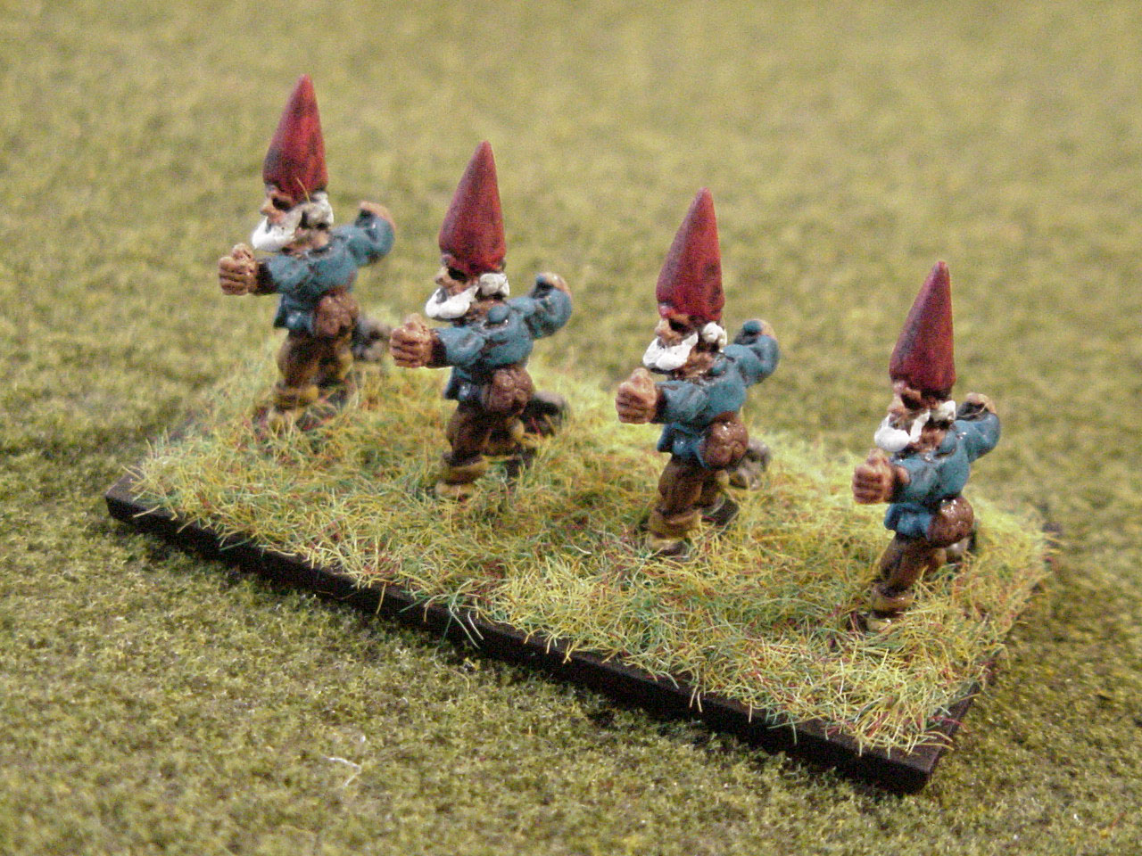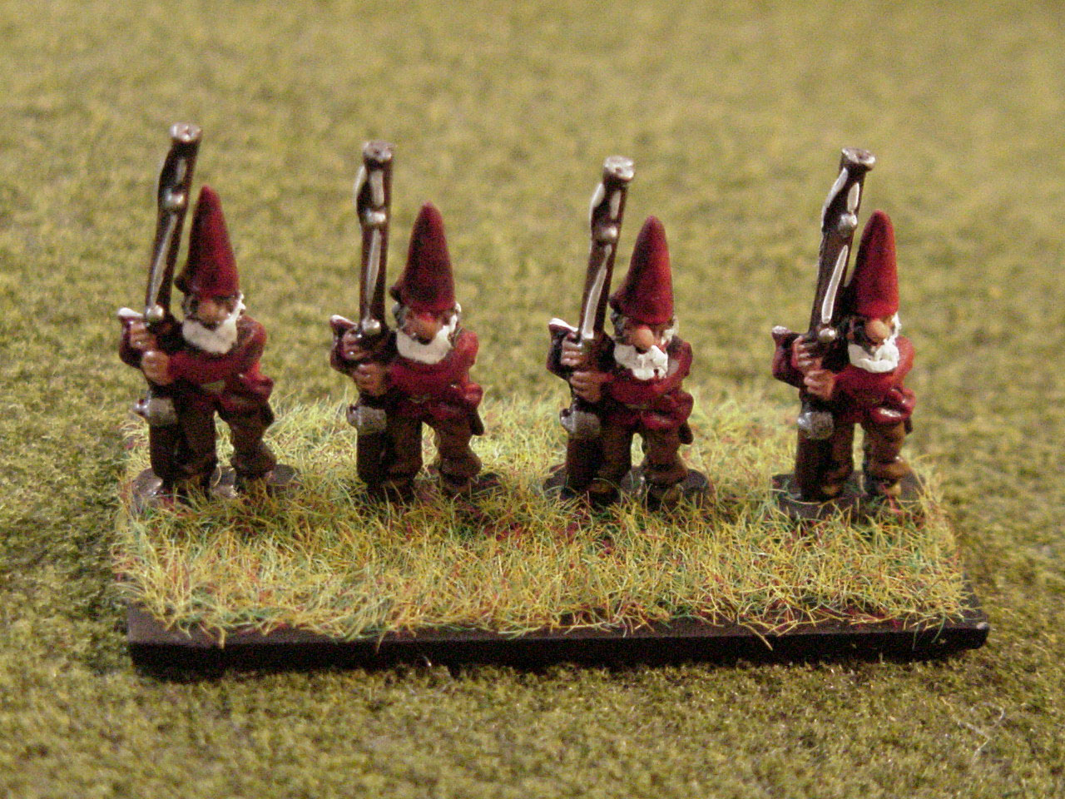

Just this simple addition allows for the Dwarves to be competitive. Put a few units of these little guys out front. They probably won’t take out a stand of charging knights, but they will slow your opponent down. They will allow you to maneuver your troops, and maybe even affect a counter-charge. Upping your breakpoint from 9 to 11 helps quite a bit too.

Launching the Dwarven Airship

Addressing the problem with artillery shooting is also quite straightforward. The beautiful Dwarven airship model provides a perfect solution. After several trial-and-error games, our gaming group created the following rules for the Dwarven airship. The Dwarven airship is a unique Dwarven hero character (only one allowed in an army). Its stat line is:

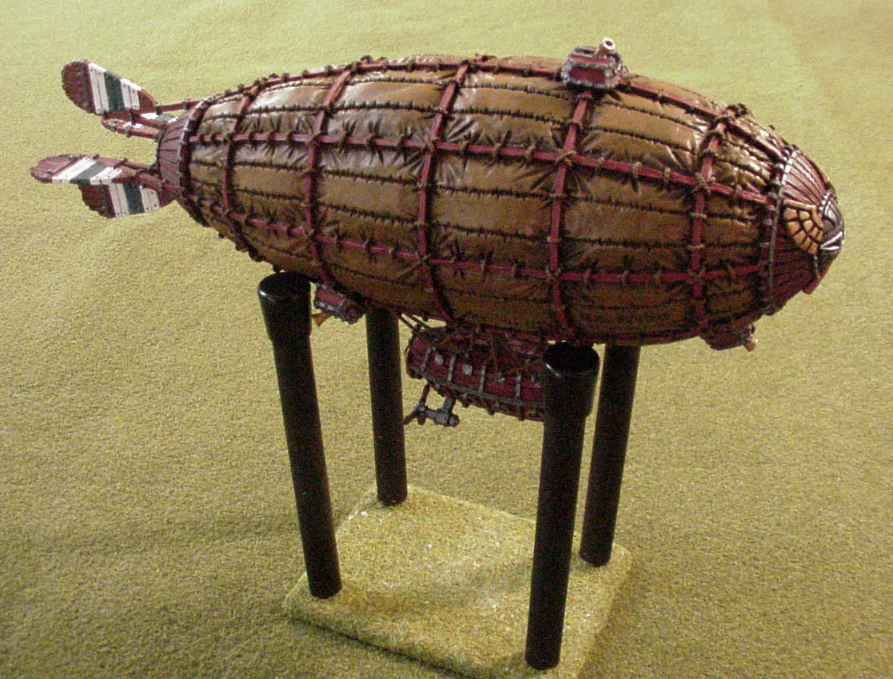

It has the following special rules:

- May move into contact with one enemy unit during the character movement phase. The airship only moves 20cm.
- Any Dwarven artillery within shooting range can target the contacted unit ignoring the usual requirement to fire at the closest enemy unit.

You should note that the Dwarven airship has no Command value and no Attacks. Thus, it cannot command any troops on the battlefield (your hero is 1000 feet in the air, after all). It cannot be overrun and therefore has no need to ever attach to a friendly unit. It is simply a slow-moving balloon that parks itself over enemy targets. At a 20cm move, the Dwarven general must use careful strategy to get the airship into position to be useful. Its effects can be devastating, however, as drive back from cannons can spoil the hardiest uber-knight charge.

Restoring the Balance

These two simple changes can pump the life back into your Dwarven war efforts. After suffering through a 2-14 slump with the original Dwarven army roster, the addition of the Gnomes and Dwarven airship has brought my winning percentage up to a respectable 2-2 in my most recent games.

The Gnomes provide a good shock absorber for my opponent’s initial charge, and they can also be effective in providing some support fire during missile combat. The Dwarven airship inspires fear if nothing else. It makes the enemy general think about how to deal with the cannons that the Dwarves inevitably bring to the game. The Dwarves are no longer the preferred enemy to draw in our bi-weekly meetings. Respect and beer, that’s all we ask!

More Craziness

If you are bent on adding monsters to the Dwarven army, I have found the addition of some Gnome giant snails to be just the answer. The stat line that seems to work the best is:

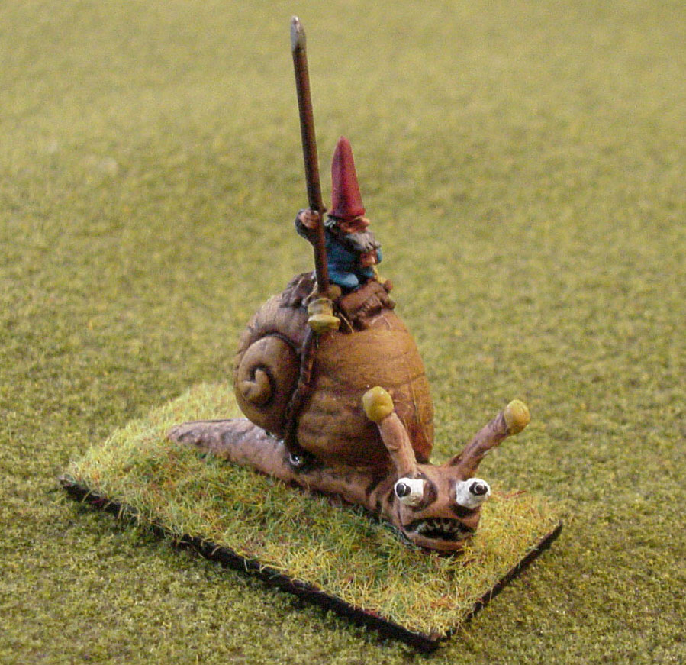

We play that giant snails can only be brigaded with other giant snails. One giant snail is allowed per 1000 points. They cause terror, no doubt. Because of their snail-like nature, however, they can move only once per turn. Now, we are still playtesting these little guys, but for those of you who bemoan the lack of monsters in the Dwarven army, this is a fun answer.

Finally, there is a question about the leaders of the Gnome nation. How can you have troops and no commanders? While I dislike adding magic to the Dwarven army, the following statistics for the Gnome mage is entertaining. I strongly suggest that if you add this character to your army that all orders to Gnome units must come from the mage. Otherwise, he becomes an independent spellcaster and loses the flavor of being the wizardly commander of the Gnomes.

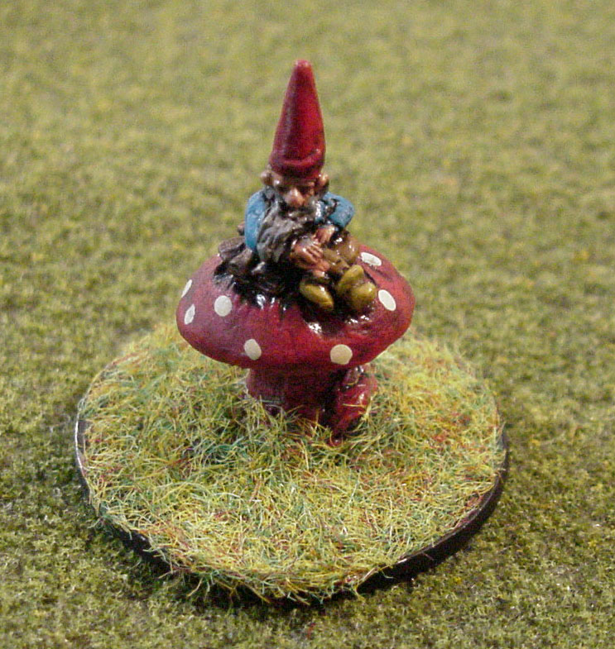

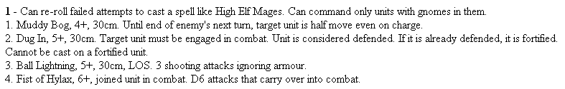

About the Author

Christopher Matney is an avid Warmaster player having played almost 200 matches since first being introduced to the game in 2001. He runs Warmaster tournaments at Denver's two gaming conventions, GenghisCon and Tacticon; organizes bi-weekly Warmaster club events at Valhallas Game Center and manages a Warmaster website at www.dragonsford.com/warmaster.

