Board One Scenario: Oceanfront Property (1A)

In this scenario, the two armies start on either side of the Sirendell River – one on the north side, the other on the south side. Only the triangle delta of land is unclaimed at the beginning of the game. There is an empty garrison fort that provides incentive to hold the delta.

Cards | Condition
Draw 3 cards | Winning the battle.
Draw 2 cards | Losing the battle.
Draw 1 card | Holding the garrison at the end of the battle.

Terrain
- RIVERS & BRIDGES: All rivers are stop-and-go for infantry only. All other units must use a bridge. Bridges do not block line of sight. A unit must have one stand flush with the river to cross it. A brigade must have one unit flush with the river to cross it. You may stand and fight in the river without penalty, but you may not redeploy or evade over the river. Shooting drive backs into the river cause confusion.
- GARRISON: You may claim the garrison if you have a unit (or partial unit) of infantry in full-edge contact with the garrison at the beginning of your movement phase AND your enemy does not have any units in contact with the garrison. Moving into a garrison is an INITIATIVE command (i.e., does not require an order). Place one unit (and one unit only - up to three stands) in the garrison. They now count as fortified, cannot be flanked, and cannot be initiative charged. Subsequent enemy units in contact with the garrison may attack the defenders as normal using the fortified rule. If all stands in the garrison are eliminated, the garrison is lost and available to be re-occupied using the rules above.

If a unit in the garrison has missile weapons, they can take full shots from the garrison following the usual rules for shooting at the closest enemy. NOTE: The position of the stands in the model is irrelevant. Treat the unit inside as if it occupies the entire structure and can fire 360 degrees.

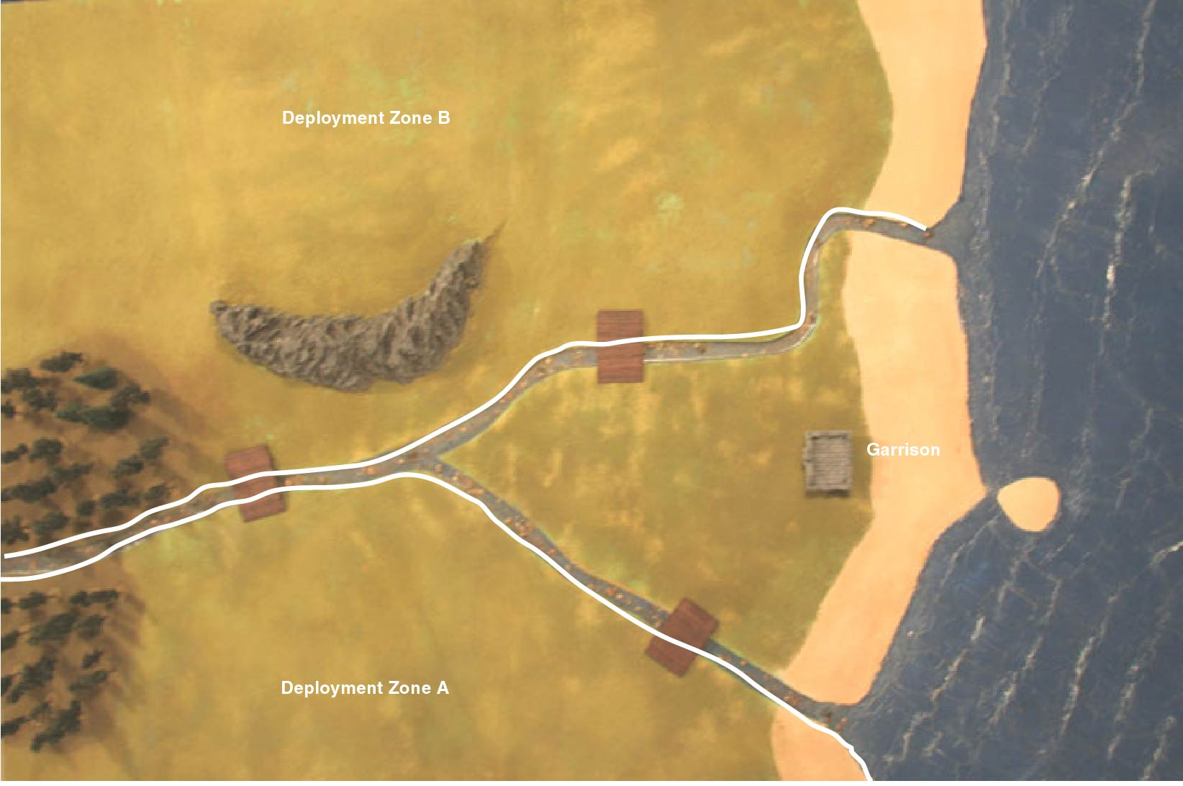

Board One Scenario: Amphibious Assault (1B)

In this scenario, one army (the attacker) starts on the shores of the Great Sea. In order to supply their invasion force, they must get supplies up the Sirendell River while defeating the defenders. The defenders get three towers at the beginning of the game. In this scenario, the defender must deploy all of its units first. Then, the attacker deploys all of its units. The attacker always moves first.

Cards | Condition
Draw 2 cards | Winning the battle.
Draw 1 card | Losing the battle.
Draw 1 card | Attacker: Getting 4 stands off the far (left) edge of the board with ½ or more of stand in each unit intact.  Defender: Allowing no units off the far (left) edge of the board.
Draw 1 card | Attacker: Safely escorting your supply boat off the map.  Defender: Destroying the supply boat.

Terrain
- SUPPLY BOAT: Your boat moves up river following the layout on the map. You can either choose a northern or southern fork of the river. The boat carries supplies, but no troops. The boat can’t fire and can be attacked only as described below. The boat moves at the end of the defender’s turn. Boat movement is mandatory. At the end of the sixth turn, the boat leaves the map. The boat takes 4 hits to be destroyed.
- GUARD TOWERS: Each of the three guard towers contains a single large ballista designed to sink boats coming up the river. The northern tower can shoot at a boat in position 3 (north fork). The center tower can shoot at a boat in position 4. The western tower can shoot at a boat in position 6. The towers cannot shoot at troops. A roll of a 4+ indicates a ballista hit and damages a boat. Towers and their ballista can be destroyed by eliminating all enemy units within a 10cm move of the tower and bringing one unit into contact with the tower base. Towers do block line of sight. Remove tower models from the game when destroyed.
- RIVERS & BRIDGES: The rivers are stop-and-go for infantry only. All other units must use a bridge. Bridges do not block line of sight. In addition, the defender gets a single shot at a boat if they have at least one unit (with at least two stands) of missile troops within 10cm the bridge. This occurs at position 2 (north fork), position 3 (south fork) and position 5. Again, a roll of a 4+ indicates a hit against a boat. The rule about shooting at the nearest target is ignored in this situation, and the missile troops designated as getting the shot cannot shoot at other targets.
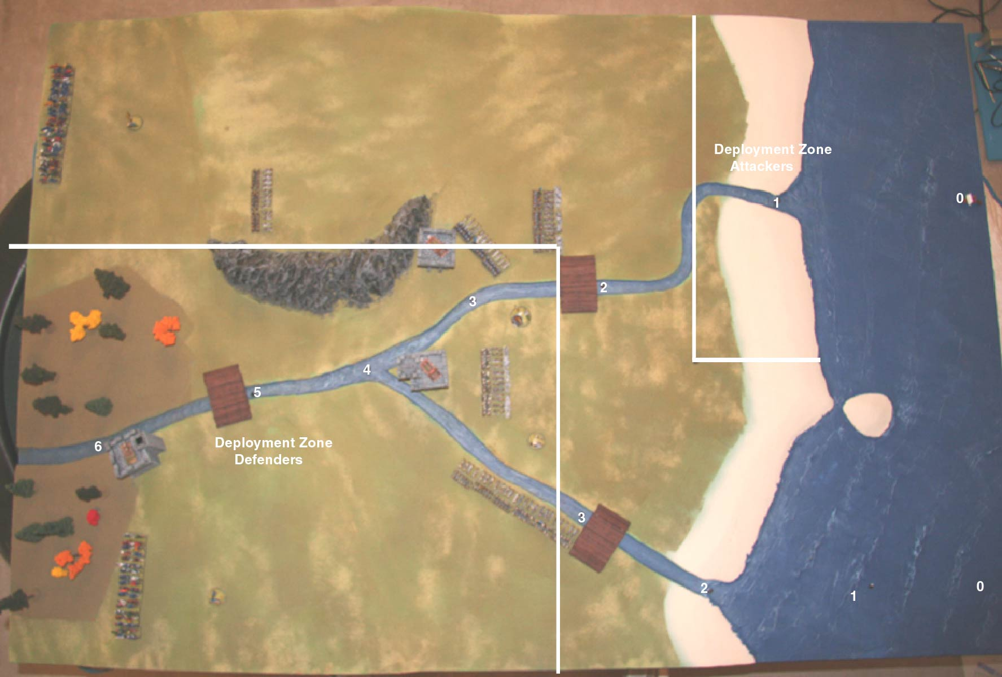
Board Two Scenario: Running the Rapids (2A)

The snaking Sirendell River winds back and forth upon itself several times in the lowlands of the Reaches. In this scenario, the only thing separating you and your enemy is the river. However, you have an important message that you must get to your spy network behind enemy lines. Designate one non-flying, non-character unit (secretly) with a small round sticker. If you can move even one stand of that unit off your opponent’s side of the board, then your message has been delivered successfully. Once the unit has left the board, it may not re-enter.

Cards | Condition
Draw 3 cards | Winning the battle.
Draw 2 cards | Losing the battle.
Draw 1 card | Successfully getting your spy off the edge of the board.

Terrain
- RIVERS & BRIDGES: All rivers are stop-and-go for infantry only. All other units must use a bridge. Bridges do not block line of sight. A unit must have one stand flush with the river to cross it. A brigade must have one unit flush with the river to cross it. You may stand and fight in the river without penalty, but you may not redeploy or evade over the river. Shooting drive backs into the river cause confusion.
- SWAMP: The swamp cannot be crossed except by infantry. The swamp gives negative modifiers for command, but it does not block line-of-sight. Movement is full.
- FOREST: The forest blocks line-of-sight for all artillery fire.
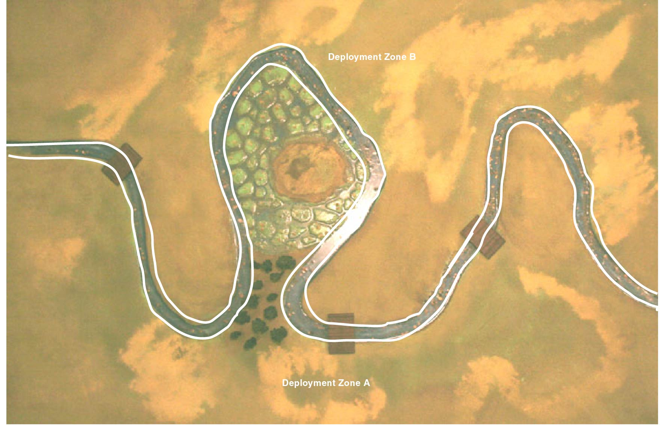

Board Two Scenario: Bruiser Breakout (2B)

The snaking Sirendell River winds back and forth upon itself several times in the lowlands of the Reaches. There, four prisons are located. In these prisons are monstrous units, potential allies in your battle against your lifelong enemy. The enemy army has been spotted, but you might have enough time to rescue the monsters and unleash their fury.

Cards | Condition
Draw 3 cards | Winning the battle.
Draw 2 cards | Losing the battle.
Draw 1 card | Destroying the most prisons. If no prisons are destroyed, no cards are drawn. If both players are tied in the number of prisons destroyed, then each draw a card.

Terrain
- RIVERS: On this map, the Sirendell River is wide and slow – there are no bridges. All units can stop-and-go at the river’s edge as long as one stand has its front edge along the riverbank before crossing. You may stand and fight in the river without penalty, but you may not redeploy or evade over the river. Shooting drive backs into the river cause confusion.
- SWAMP: The swamp cannot be crossed except by infantry. The swamp gives negative modifiers for command, but it does not block line-of-sight. Movement is full.
- PRISONS: Each of the four prisons contains reinforcements for your side – monstrous allies. However, they also each contain a unit of goblin archers in a fortified position. Bummer. The goblins have 360 degree facing; can shoot in any direction (no flanking). They must shoot at the closest enemy unit, of course. The goblins shoot at the end of each player’s turn.
- MONSTERS IN CHAINS: The monsters inside the prison cannot do anything until they are released. Once a prison is destroyed, replace the prison model with the appropriate captive unit. At this point, they become another unit in your army and can be commanded in the normal way. They are allowed to redeploy on the turn they are released. However, they cannot be brigaded with your forces. The two interior prisons each contain a unit of ogres. The two exterior prisons each contain a unit of giants. NOTE: Adding a monster does not change your army’s breakpoint.
- DESTROYING GOBLINS AND PRISONS: Goblins can be attacked in the usual way – shooting, spells or melee. The goblins are fortified enemy units following all the standard Warmaster rules. Once the goblins are destroyed, bringing a single unit (excluding fliers and characters) with ½ or more of its stands intact into contact with prison base destroys it. NOTE: Nearby enemy troops do not need to be eliminated in order to destroy the prison.
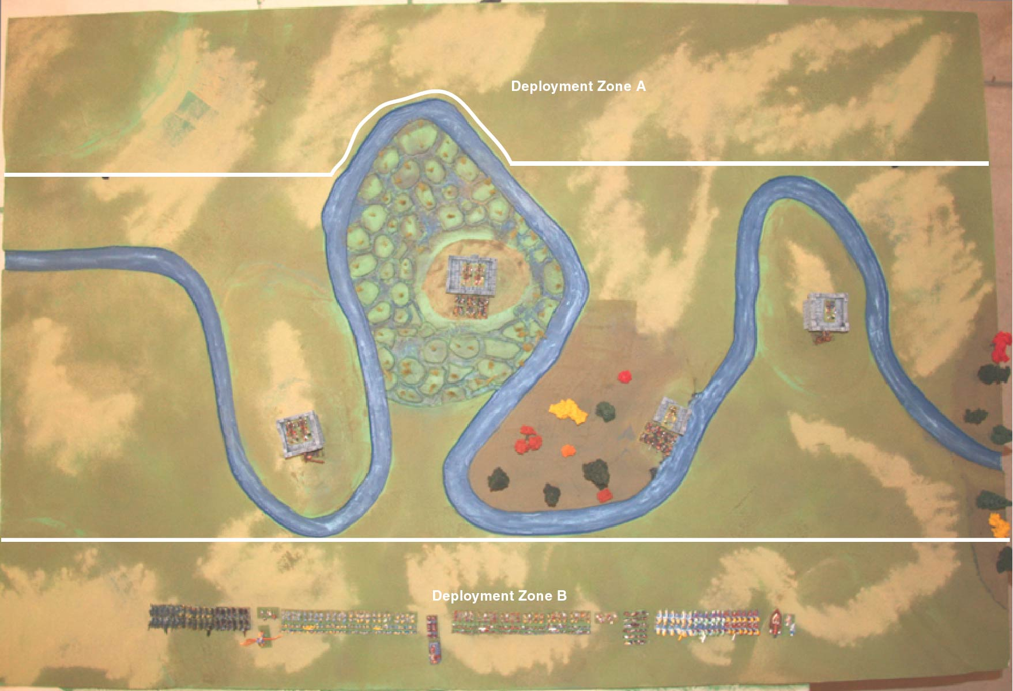

Board Three Scenario: Over the River and Through the Woods (3A)

This scenario is a big battle for the center of the board. NOTE: You can deploy units on the far side of the river but each STAND must be touching the river. This will put some units in irregular formations when deployed. It also allows for a very quick engagement.

In addition, you have an important message that you must get to your spy network behind enemy lines. Designate one non-flying, non-character unit (secretly) with a small round sticker. If you can move even one stand of that unit off your opponent’s side of the board (i.e., off any edge within their deployment zone), then your message has been delivered successfully. Once the unit has left the board, it may not re-enter.

Cards | Condition
Draw 3 cards | Winning the battle.
Draw 2 cards | Losing the battle.
Draw 1 card | Successfully getting your spy off the edge of the board.

Terrain
- RIVERS & BRIDGES: All rivers are stop-and-go for infantry only. All other units must use a bridge. Bridges do not block line of sight. A unit must have one stand flush with the river to cross it. A brigade must have one unit flush with the river to cross it. You may stand and fight in the river without penalty, but you may not redeploy or evade over the river. Shooting drive backs into the river cause confusion.
- RUINS: You cannot deploy any troops or move any troops in the ruins on the far south edge of the board. The ruins block line of sight.

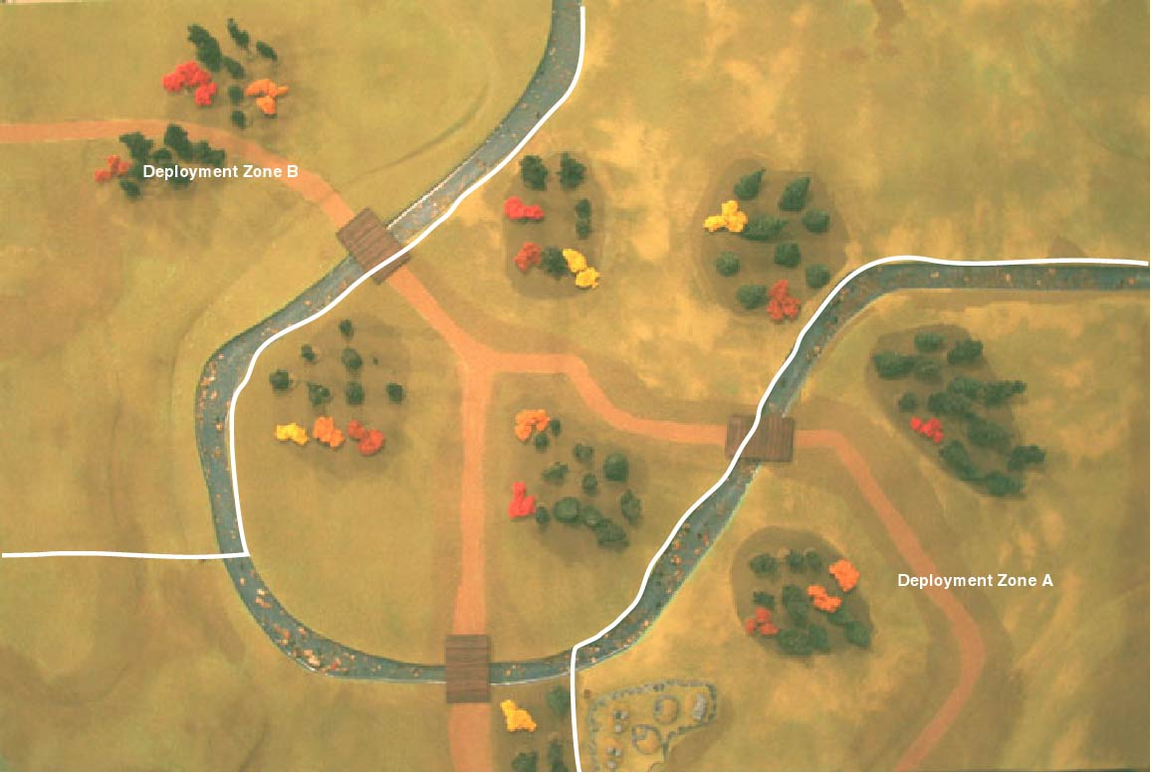
Board Three Scenario: Wagons Ho! (3B)

In this scenario, the attacking army stumbles upon an enemy supply train, taking food and supplies to their allies. The area is heavily forested, and you fear that the defenders might simply fade into the woods unless you can strike quickly. In this scenario, the defender (with the supply train) sets up all of its units first. Each unit in the defender’s army must start touching road. The attacker sets up second. The defender moves first.

Cards | Condition
2 cards | Winning the battle.
1 card | Losing the battle.
1 card | Attacker: Destroying two or more supply wagons.  Defender: Losing no supply wagons.
1 card | Attacker: Keeping the enemy from getting any units off the board.  Defender: Getting 4 or more units (excluding fliers and characters) off the far (left) edge of the board with ½ or more of its stands.

TERRAIN
- SUPPLY WAGONS: Supply wagons can be destroyed by bringing one unit (excluding fliers and characters) with ½ or more of its stands intact into contact with the wagon base. You may not initiative charge a supply wagon. Units attempting to destroy a supply wagon do so in the main combat phase (after shooting) and may not undertake any other action during the turn (including redeployment). Simply declare the supply wagon destroyed and remove it from the game. Supply wagons move 30cm along the road, 20cm in the open, and cannot enter the forest. Supply wagons are not commanded and get one move per turn in the character movement phase. NOTE: Nearby enemy troops do not need to be eliminated in order to destroy the supply wagons.
- SCOUTING PARTIES: The attacker may deploy up to 250 pts of troops in either or both of the circular deployment zones shown on the map. These are your advanced scouting parties.
- RIVERS & BRIDGES: All rivers are stop-and-go for infantry only. All other units must use a bridge. Bridges do not block line of sight. A unit must have one stand flush with the river to cross it. A brigade must have one unit flush with the river to cross it. You may stand and fight in the river without penalty, but you may not redeploy or evade over the river. Shooting drive backs into the river cause confusion.
- RUINS: You cannot deploy any troops or move any troops in the ruins on the far south edge of the board. The ruins block line of sight.

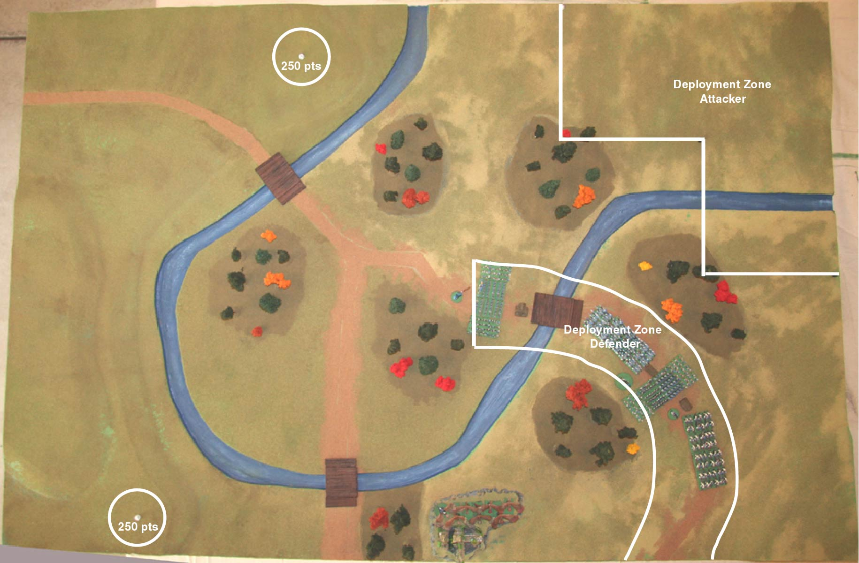

Scenario Four - Purple Mountains Majesty (4A)

The riches of the Shadowyarn mines await the victor on this map. In this scenario, each army starts very near each other in the center of the board. There is an empty garrison fort that provides incentive to hold the plains.

Cards | Condition
Draw 3 cards | Winning the battle.
Draw 2 cards | Losing the battle.
Draw 1 card | Holding the garrison at the end of the battle.

Terrain
- WALLS: The earthwork walls allow for archers and artillery on higher ground to shoot down upon their hapless victims. Walls and ramps afford defended status.
- GARRISON: You may claim the garrison if you have a unit (or partial unit) of infantry in full-edge contact with the garrison at the beginning of your movement phase AND your enemy does not have any units in contact with the garrison. Moving into a garrison is an INITIATIVE command. Place one unit (and one unit only - up to three stands) in the garrison. They now count as fortified, cannot be flanked, and cannot be initiative charged. Subsequent enemy units in contact with the garrison may attack the defenders as normal using the fortified rule. If all stands in the garrison are eliminated, the garrison is lost and available to be re-occupied using the rules above.

If a unit in the garrison has missile weapons, they can take full shots from the garrison following the usual rules for closest enemy. NOTE: The position of the stands in the model is irrelevant. Treat the unit inside as if it occupies the entire structure and can fire 360 degrees.

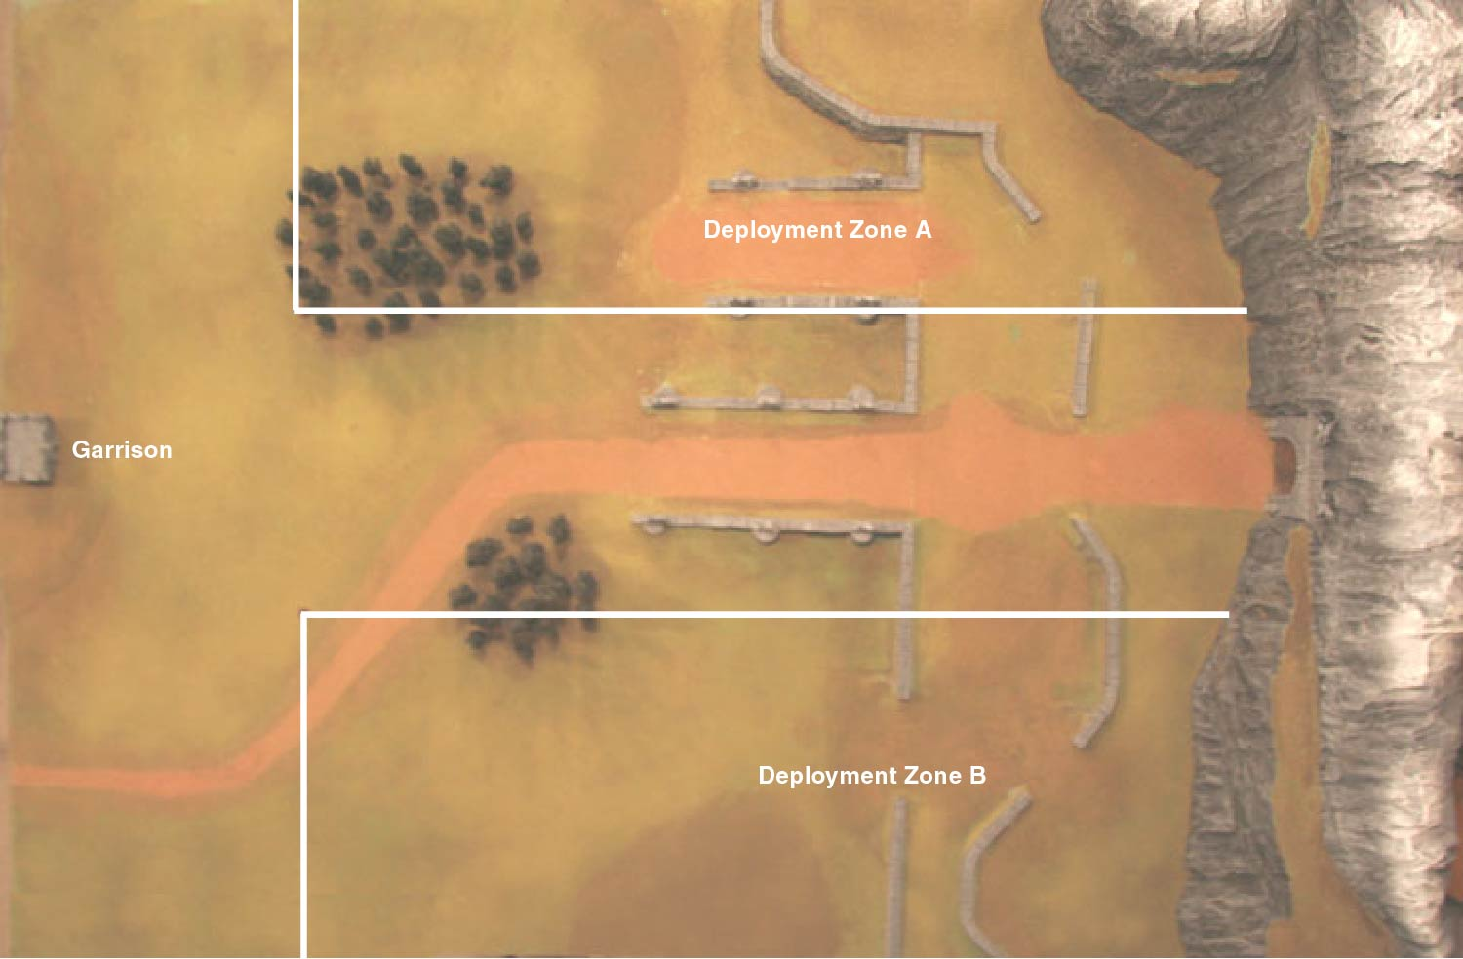

Table Four Scenario: Shadowyarn Siege (4B)

In this scenario, your army reaches the dwarven stronghold and must defeat the entrenched defenders. You have managed to construct a single trebuchet to help you in your fight. Additionally, the stronghold has a massive golden door behind which is trapped an angry blue dragon captured by the defenders. Opening the door releases the dragon to fight for your side. In this scenario, the defender deploys all of its troops first. The attacker deploys its troops second. The attacker moves first.

Cards | Condition
3 cards | Winning the battle.
2 cards | Losing the battle.
2 cards | Attacker: Opening the dragon door.
1 card | Defender: Destroying the trebuchet.

TERRAIN
- DRAGON: The dragon inside the mountain cannot do anything until it is released. The dragon door may be opened by getting any unit (excluding fliers and characters) with ½ or more of its stands intact in contact with the door. The door opens immediately. Once opened, the player gets a dragon to aid them in their conquest of the dwarves. The dragon is allowed to redeploy on the turn it is released. However, it cannot be brigaded with your forces. NOTE: Adding the dragon does not affect breakpoint.
- TREBUCHET: The trebuchet may be deployed anywhere in your deployment zone. Once placed, it cannot be moved. The trebuchet does not add to your breakpoint. NOTE: Unlike “normal” trebuchets, a blind shot with this device can target units that can’t be seen AND ignore the closest unit rule. All other rules apply to the trebuchet.
- RAMPS: Because they are smooth and paved, none of the ramps (openings in the wall) afford defended status for higher ground, and charging defenders on the ramps count as “in the open”. The walls themselves do afford defended status for troops behind them.
