Valhalla’s Mighty Empires Campaign

Introduction 1
The Map 3
Special Locations 3
Campaign Rounds 4
Orders Phase 4
Battle Phase 5
Post-Battle Phase 8
Destroying Empires 9
Winning the Campaign 9

Introduction

This is a Warmaster Campaign designed to be played in 8 meetings.

There are four empires in the game. Each empire is represented by a team of between one and four players. These empires are: Good, Evil, Lawful, and Chaos. Note that in this campaign it is not strictly necessary that every member of each team participate in every round. The system can accommodate periodic absences, holidays, and occasional participants, as well as unexpected visitors.

At the start of the campaign, one player in each empire is elected as overall ruler. The overall ruler decides where to attack either in consultation with his team or not as he
pleases. It’s great to be King!

Each empire is a great realm full of bustling cities, towns, and villages, each supplying troops for the empire’s armies. These are not represented directly on the map. Similarly, we will not represent forces on the map itself; instead it is considered that the empires have armies and garrisons stationed within them. During each turn, the empire’s forces are ready to give battle, to defend the borders, or to invade deep into enemy territory. The base army size for the campaign in 2000 pts.

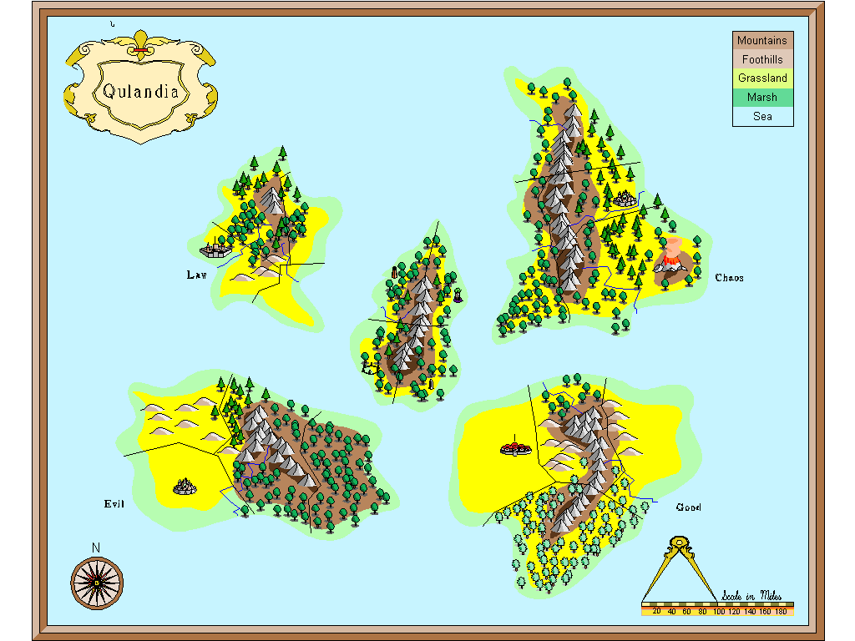

The Map

At the start of the campaign, each empire consists of a capital tile plus all the adjoining tiles – ie, seven tiles in total. Place an appropriate territory marker in each of these tiles (see below).
If the capital lies on the sea or the map edge some of the player’s territory will be lost, in which case the empire will be slightly smaller than normal.

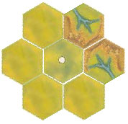

Special Locations

The map includes special locations such as mines, wizard’s towers, necropoli, and so on. These are represented by the appropriate counters.
Special Location | Game Bonus
Mine | Mighty Armour – the player can re-roll all the Armour rolls for any one unit once during the battle.
Wizard's Tower | Mighty Magic – the player can cast a spell automatically once during the battle – the dice is not rolled and the spell is cast as if a successful roll had been made.
Necropolis | Might of the Ancestors – the player can add +1 extra attack to one unit during each turn – the bonus applies to that unit in each combat round that turn. As the effect is used from turn to turn it can be applied to a different unit each turn – but only to one unit in any turn. Note that this is +1 attack in total – not +1 attack per stand.
Temple | Might of the Gods – the player can dispel one enemy spell once per battle in the same way as a Dispel scroll.
Stone Circle | Might of Stone – the player can force his opponent to re-roll the dice when he casts a spell. This power continues to work until his opponent scores a successfully Cast on a re roll.
Bridges | Bridges do not confer an in-game bonus but allow attacking empires to trace a route across rivers as noted below. If a player places bridges as a special location he can place up to three.

Campaign Rounds

The campaign is divided into rounds. Each round consists of three phases. We’ve used the term rounds rather than turns simply to make the distinction between turns during a battle.

- Orders phase
- Battle phase
- Post-Battle phase

Orders Phase

In the Orders phase, each empire secretly indicates which enemy empire it will attack. The players write down or otherwise indicate their targets and all reveal at the same time. (Note: we found it convenient to use the coloured empire counters, each player holding the appropriate counter in his fist and then all players revealing their counters at once). An empire can only attack another empire if at least one enemy territory lies within three tiles of one of its own territories. In addition, there must be a clear route to the empire that is to be attacked. A mountain tile edge, a river without a bridge, a swamp, a lake, and open sea tiles all block the route. When determining the route, do not count the edge of the tile the route is being taken from – only the edges of the tiles being ‘routed’ through (see below).

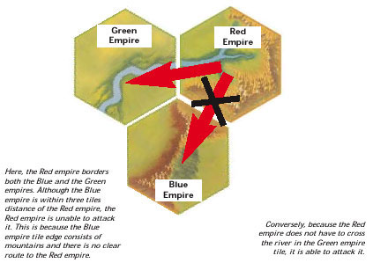

In the event that an empire cannot make an attack (it is either more than three tiles away from another empire or all of its attack routes are blocked by terrain) then it may attack the closest empire as the crow flies.

Battle Phase

Once orders are revealed, the attack arrows are placed on the map to show where attacks have been launched. The purpose of the arrows is simply to make it easier to see what is going on. Place each coloured arrow so that it points from its empire and towards the target. Not all attacks will necessarily succeed. Begin by working out which attacks succeed. If an empire is not being attacked, its own attack succeeds automatically. The target empire’s attack is cancelled and its attack arrow is removed. The target empire’s own target is no longer being attacked so its own attack now succeeds – and so on. Once you have worked through this process, all the remaining arrows show successful attacks. Note that this will include situations where two empires are attacking each other if no others are involved, as well as attacks from those empires that have not been successfully attacked.

In this situation below, the players have all decided their orders and placed the attack arrows on the map to indicate which empire is attacking which. The Red and Blue empires have decided to attack each other which is fairly straightforward. However, the Green empire has also decided to attack the Blue empire and because the Green empire isn’t under attack itself, the attack will go through negating the Blue attack. In the Battle phase, the Red and Green empires will form an allied army against the Blue empire.

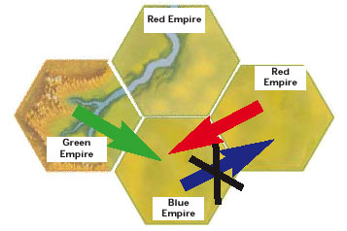

In the situation below, the players have all decided their orders and placed the attack arrows to indicate which empire is attacking which. The Yellow and Blue empires have decided to gang up upon the Red empire and attack simultaneously but because the Green empire has attacked the Yellow empire and isn’t under attack itself, Yellow’s attack on the Red empire is nullified and the Yellow empire must play a battle against the Green empire instead.

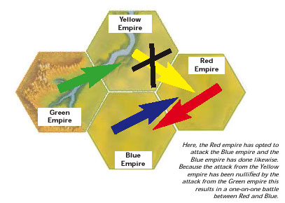

Note that it is theoretically possible for no attacks to succeed – ie, all the attack arrows have been removed – in which case play another round. This can only happen if all the empires attack their neighbour to their left or right – forming a complete circle with no mutual attackers. We have never known this occur!

Once successful attacks have been established battles are fought between players from the warring empires.

If two empires are attacking each other then the players simply pair off. This is done by a random roll of the dice.

If there are more players on one side than another, excess players double up with their team mates to fight two on one battles using the allied rules. If necessary fight three on one, four on one and so on, so that all the players are taking part.

No. of Allies | Total army size
2 | 2500 ( 2 armies of 1250)
3 | 3000 ( 3 armies of 1000)
4 | 3500 (4 armies of 875)

Each army is chosen in the regular way and must adhere to the usual choice restrictions for an army of that size – i.e. it must include a general and appropriate minimum numbers of certain troops.

For all intents and purposes, the allied armies are separate entities with separate ‘break points’ that move and fight in the same turn. It is entirely possible for the defender in a multi-player scenario to force one (or more) allied armies to withdraw and then be forced to withdraw himself by those allied armies that remain. If the defender manages to force the majority of the attacking armies to withdraw (both armies with two attackers, two armies with three attackers, three armies with four attackers and so on...) then he scores a win and all of the attacking armies lose. If the attackers force the defender to withdraw and still have more than half of their armies on the battlefield, then the attacking armies remaining on the battlefield score a win (allied armies that are forced to withdraw always lose). Any other outcome results in a draw. Victory points only count when determining the order empires may claim territories.

When fighting battles as allies, each army deploys opposite the enemy within the same deployment zone. Each of the allied armies must be deployed in its own designated part of the allied deployment zone (ie, if there are three allied armies, divide the deployment zone into three areas). This helps to keep each of the armies together and prevents units becoming isolated from characters. All allies move and fight in the same turn as though they were a single army. The only way in which an allied army differs to an individual army is that orders may only be issued to units belonging to the same original army as the character issuing it.

If two or more empires are successfully attacking another, begin by allocating all the players from the attacked empire to opponents. Alternate between enemies starting with the most numerous. So, if there are five Red players taking on an alliance of five Blue and three yellow allocate Red to Blue, Red to Yellow, Red to Blue, Red to Yellow, and Red to Blue. Finally, randomly allocate the remaining attacking players to existing battles. This will result in two on one battles with allied armies from the same or different empires depending on the draw.

Any in-game benefits from special locations apply only to the individual player who owns the corresponding territory – they do not apply to the empire as a whole or to entire allied armies.

Post-Battle Phase

During the post-battle phase, empires acquire or lose territory depending on their success in battle. Determine how many battles each empire has lost, won, or drawn that round. Allocate campaign points as follows.

3 pts | The empire has won more battles than it has drawn/lost.
2 pts | The empire has neither won more battles than it has drawn/lost nor lost more battles than he has drawn/won.
1 pts | The empire has lost more battles than it has won/drawn.

In descending order starting with the empire who scored the most campaign points, the king can add territories to his empire. Note that in some cases an empire may have insufficient campaign points to add a territory – in which case no territory is added that round and any excess campaign points are lost. The campaign points earned that round are used to acquire territory – this can be one, two or potentially three tiles. The chart below lists the points required.

3 pts | To capture an adjacent territory tile from the empire fought against that round. The enemy’s territory marker is removed and your own is placed there instead.
2 pts | To remove an adjacent territory tile from the empire fought against that round. The enemy’s territory marker is removed and the tile reverts to unclaimed wilderness.
1 pts | To occupy a tile adjacent to the empire’s own territory and which does not already form part of another empire. If the king has two or three points to spend he can therefore add two or three territories to his empire: in this case add one territory at a time and subsequent territories can be placed next to ones already placed if the player wishes.

Destroying Empires

If an empire loses its capital tile then it is destroyed and is out of the campaign. All of the territories that were previously part of the empire immediately revert to unoccupied land and all territory markers are removed.

A capital can only be destroyed if it is the specific target of an attack. This is called a capital assault. To make a capital assault, the attacking empire must already own a territory tile that is adjacent to the capital tile.

At the start of the Orders phase the attacking empire(s) must openly announce that it is
going to launch a capital assault. The king positions his attack arrow accordingly and then
the remaining players work out their attacks secretly in the usual manner. Note that this
gives the other players an opportunity to negate the capital assault by attacking the empire(s) making the assault.

Instead of a standard pitched battle, play a game of siege using the final scenario (3) and rules from Warmag 9 ‘Into the Breach’. If the attackers win, they have captured the enemy capital and thrown down that empire.

Winning the Campaign

The campaign will last 8 meetings (ending December 18, 2003) or until one empire has conquered half of the territory tiles on the map. The empire that has the largest territory once all the rounds have been played is the winner.

