Mighty Empires of the Realm Campaign

Introduction 1
Map of the Realm 2
Campaign Rounds 3
Orders Phase 3
Battle Phase 3
Post-Battle Phase 5
Magic Item and Tactic Cards 6
Useless Cards 6
Destroying Empires 7
Winning the Campaign 7

Introduction

This is a Warmaster Campaign designed to be played in 14 meetings.

There are four empires in the game. Each empire is represented by a team of between one and four players. Note that in this campaign it is not strictly necessary that every member of each team participate in every round. The system can accommodate periodic absences, holidays, and occasional participants, as well as unexpected visitors.

At the start of the campaign, one player in each empire is elected as overall ruler. The overall ruler decides where to attack either in consultation with his team or not as he pleases. It’s great to be King!

Each empire is a great realm full of bustling cities, towns, and villages, each supplying troops for the empire’s armies. These are not represented directly on the map. Similarly, we do not represent forces on the map itself; instead it is considered that the empires have armies and garrisons stationed within them. During each turn, the empire’s forces are ready to give battle, to defend the borders, or to invade deep into enemy territory. The base army size for the campaign in 2000 pts.

Map of the Realm

At the start of the campaign, each empire consists of a capital territory (as shown on the map below).

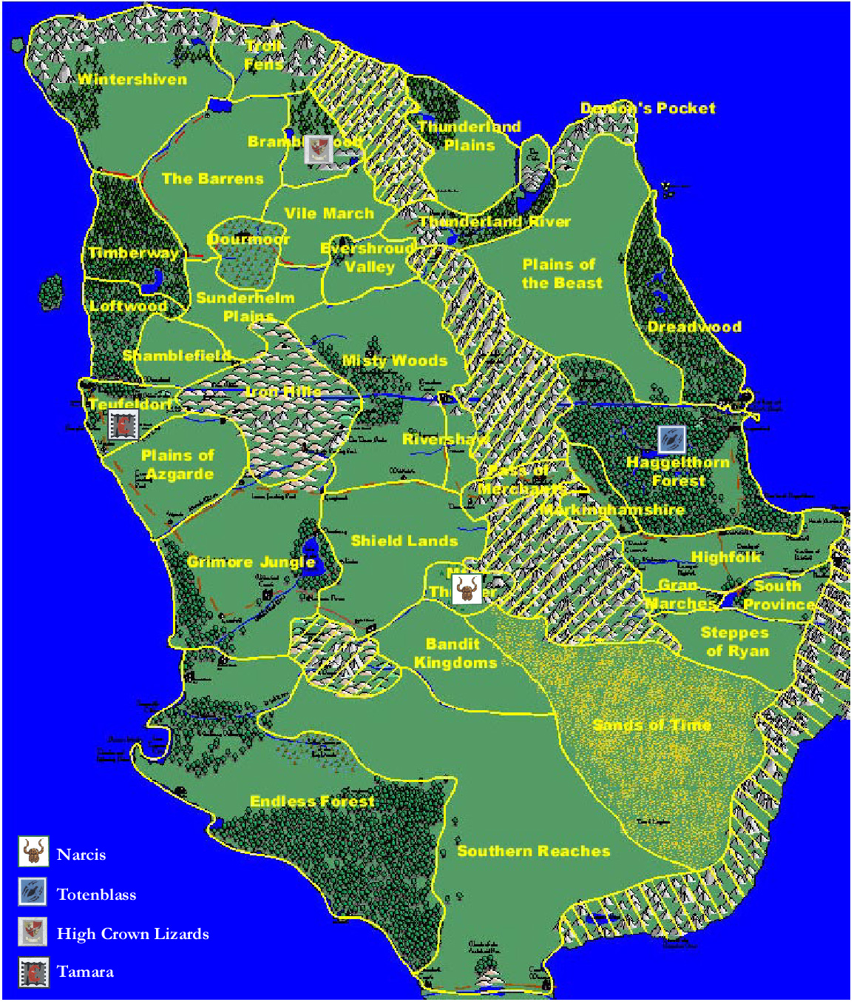

Campaign Rounds

The campaign is divided into rounds. Each round consists of three phases. We’ve used the term rounds rather than turns simply to make the distinction between turns during a battle.

- Orders phase
- Battle phase
- Post-Battle phase

Orders Phase

In the Orders phase, each empire secretly indicates which enemy empire it will attack. The players write down or otherwise indicate their targets and all reveal at the same time. (Note: we found it convenient to use the coloured empire counters, each player holding the appropriate counter in his fist and then all players revealing their counters at once). An empire can only attack another empire if at least one enemy territory lies within three moves of one of its own territories. In addition, there must be a clear route to the empire that is to be attacked. Impassable mountain and open seas block the route.
__________________________________________________________________

Note: During the first two rounds of the campaign, any attacks are allowed regardless of distance.
__________________________________________________________________

In the event that an empire cannot make an attack (it is either more than three territories away from another empire or all of its attack routes are blocked by terrain) then it may attack the closest empire as the crow flies.

Battle Phase

Once orders are revealed, the attack arrows are placed on the map to show where attacks have been launched. The purpose of the arrows is simply to make it easier to see what is going on. Place each coloured arrow so that it points from its empire and towards the target. Not all attacks will necessarily succeed. Begin by working out which attacks succeed. If an empire is not being attacked, its own attack succeeds automatically. The target empire’s attack is cancelled and its attack arrow is removed. The target empire’s own target is no longer being attacked so its own attack now succeeds – and so on. Once you have worked through this process, all the remaining arrows show successful attacks. Note that this will include situations where two empires are attacking each other if no others are involved, as well as attacks from those empires that have not been successfully attacked.
__________________________________________________________________

Note: This process results in an unambiguous result only 78% of the time. The table at the end of these rules has been developed to provide fair results in all cases.
__________________________________________________________________
Once successful attacks have been established, battles are fought between players from the warring empires.

If the two empires attacking each other each have the same number of players, a random roll of the dice should be used to determine the pairings.

If there are more players on one side than another, excess players double up with their team mates to fight two-on-one, three-on-one, or four-on-one battles using allied rules. This insures that all players take part each round.

No. of Allies | Total army size
2 | 2500 ( 2 armies of 1250)
3 | 3000 ( 3 armies of 1000)
4 | 3500 (4 armies of 875)

Each army is chosen in the regular way and must adhere to the usual choice restrictions for an army of that size – i.e. it must include a general and appropriate minimum numbers of certain troops.
__________________________________________________________________

Note: Allied forces can play a total of only one magic item and one tactic card in the battle.
__________________________________________________________________

For all intents and purposes, the allied armies are separate entities with separate ‘break points’ that move and fight in the same turn. It is entirely possible for the single player in a multi-player scenario to force one (or more) allied armies to withdraw and then be forced to withdraw himself by those allied armies that remain. If the single player manages to force the majority of the attacking armies to withdraw (both armies with two attackers, two armies with three attackers, three armies with four attackers) then he scores a win. If the allied armies force the single army to withdraw and still have more than half of their armies on the battlefield, then the allied armies score a win. Any other outcome results in a draw.

When fighting battles as allies, each army deploys opposite the enemy within the same deployment zone. Each of the allied armies must be deployed in its own designated part of the allied deployment zone (ie, if there are three allied armies, divide the deployment zone into three areas). This helps to keep each of the armies together and prevents units becoming isolated from characters. All allies move and fight in the same turn as though they were a single army. The only way in which an allied army differs to an individual army is that orders may only be issued to units belonging to the same original army as the character issuing it.
__________________________________________________________________

Note: The attacker chooses the scenario from any of his territories (except his capital). If the attacker has no territories, a scenario is randomly chosen from the unclaimed territories on the map.
__________________________________________________________________

Post-Battle Phase

During the post-battle phase, empires acquire or lose territory depending on their success in battle. They can also win magic item and tactic cards to be used in future battles. Determine how many battles each empire has lost, won, or drawn that round. Allocate campaign points as follows.

3 pts | The empire has won more battles than it has drawn/lost.
2 pts | The empire has neither won more battles than it has drawn/lost nor lost more battles than he has drawn/won.
1 pts | The empire has lost more battles than it has won/drawn.

In descending order starting with the empire who scored the most campaign points, the king can add territories to his empire or choose to draw magic item and/or tactic cards. Note that in some cases an empire may have insufficient campaign points to add a territory. Note also that in some cases an empire may have sufficient campaign points to acquire one, two or potentially three territories. The chart below lists the points required.

3 pts | To capture an adjacent territory from the empire fought against that round. The enemy’s territory marker is removed and your own is placed there instead.
2 pts | To remove an adjacent territory from the empire fought against that round. The enemy’s territory marker is removed and the tile reverts to unclaimed wilderness. It can not be reclaimed this round.
1 pts | To occupy a tile adjacent to the empire’s own territory and which does not already form part of another empire. If the king has two or three points to spend he can therefore add two or three territories to his empire: in this case add one territory at a time and subsequent territories can be placed next to ones already placed if the player wishes.
1 pts | To draw one card from either the magic item or tactic deck.

Magic Item and Tactic Cards

Magic item cards provide a non-standard magic item that can be added to an army. A general must announce that he is including a special magic item card with his army and reveal the card prior to setting up brigades. After setup, the player must choose which unit or character is carrying the item. In some cases, the item is played on enemy units or characters. Several examples:

Map of All Places: Play on any unit. Unit ignores -1 command penalty for dense terrain.
Banner of Misfortune: Play on any unit. Opponent can force the unit to reroll all its attack dice once per game.

At the end of the battle, all special magic cards are returned to the deck (regardless of whether they actually came into play during in the battle).
__________________________________________________________________

Note: A player may use only one magic item card each battle.

Note Also: All magic item cards are controlled by the king who may dole them out to his vassals as he sees fit. Magic item cards may not be traded among kingdoms.
__________________________________________________________________

Tactic cards provide interesting twists to the battle that can make a general think twice about how to proceed. Again, a general must announce that he is including a specific tactic card with his army. He need not reveal the card to his opponent prior to play, but he may not switch tactic cards once setup has begun. Several examples:

Haunted Terrain: Play face down on any unoccupied terrain feature. Revealed when a unit enters the feature. Evil spirits inhabit this place. Any unit partially in the feature suffers an additional -1 to command it.
Spiked Victuals: Play on any unit. The unit's rations have been spiked. They start the game confused and may not move on Turn 1.
__________________________________________________________________

Note: A player may use only one tactic card each battle.

Note Also: All tactic cards are controlled by the king who may dole them out to his vassals as he sees fit. Tactic cards may not be traded among kingdoms.
__________________________________________________________________

Useless Cards

During the post-battle phase, you may turn in 3 magic item and/or tactic cards (in any combination) for a new draw of 1 card from either deck.

Destroying Empires

If an empire loses its capital tile then it is destroyed and is out of the campaign. All of the territories that were previously part of the empire immediately revert to unoccupied land and all territory markers are removed.

A capital can only be destroyed if it is the specific target of an attack. This is called a capital assault. To make a capital assault, the attacking empire must already own a territory that is adjacent to the capital.

At the start of the Orders phase the attacking empire(s) must openly announce that it is
going to launch a capital assault. The king positions his attack arrow accordingly and then
the remaining players work out their attacks secretly in the usual manner. Note that this
gives the other players an opportunity to negate the capital assault by attacking the empire(s) making the assault.

Players in the destroyed empire are distributed among the remaining kingdoms for the remainder of the campaign.

Winning the Campaign

The campaign will last 14 meetings (through August 2004) or until one empire has conquered half of the territory tiles on the map. The empire that has the largest territory once all the rounds have been played is the winner.

