Warmaster “Gauntlet” Tournament

Think you are a Warmaster Champion? Consider the gauntlet thrown down. Come join us for a new, exciting tournament format.

On one side of the table, we have four seasoned Warmaster veterans (Chris, Brian, Bruce and Jeff), each armed with a standard army and a diabolical scenario to challenge your skills.

On the other side of the table, you and your teammate will have to decide how to best divide up these four challenges. Each of you will play two one-on-one games running the gauntlet of the four scenarios, scoring points based on your success or failure. Your team’s score will be compared to all other challengers at the Con. The team with the best overall score will be crowned Warmaster champion.

You need a standard 2000 point Warmaster army (no variants), some dice and lots of luck. Scenario descriptions will be available just prior to the Con – just drop me an email – cmatney@dragonsford.com. Loaner armies are available with prior arrangements as well. NOTE: If you don’t have a teammate in mind, no worries. Just sign up for a time slot, and we will get you paired up.

Scoring

All scenarios will use the standard Warmaster tournament scoring system as shown below. IMPORTANT NOTE: These points will be augmented by additional scenario-specific points. Each two-person team will be facing all four scenarios. Some of the scenarios have been designed to be more difficult than others, so victory in all four matches is not necessarily needed to win the tournament.

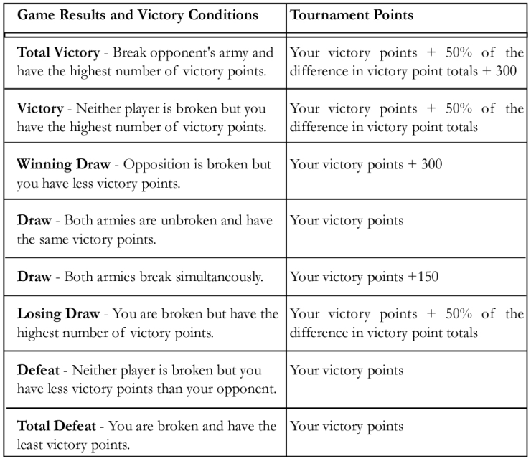
Scenario One: Invasion

In this scenario, your army starts on the shores of the Great Sea. In order to supply your invasion force, you must get supplies up the Sirendell River while defeating the first line of defense – those pesky Bretonnians and their crusading knights. In this scenario, the attacker (that means you) moves first.

OBJECTIVES
- Kill your opponent – this is war, after all.
- Defend your boat as it moves up the river.
- Take out defensive towers along the way.
- Get units off the far edge of the map.

Additional Tournament Points | Condition
50 points | Each unit (excluding fliers and characters) that gets off the far edge of the board with ½ or more of its stands intact.
100 points | Each tower destroyed.
450 points | Safely escorting your ship off the map

MECHANICS
- BOAT MOVEMENT: Your boat moves up river following the layout on the map. You can either choose a northern or southern fork of the river. Boats carry supplies, but no troops. The boats can’t fire and can be attacked only as described below. Boats move at the end of each full turn. Boat movement is mandatory. After the eighth turn, the boat leaves the map.
- GUARD TOWERS: Each of the three guard towers contains a single large ballista designed to sink boats coming up the river. The eastern tower can shoot at a boat in positions 3 and 4 (north fork). The center tower can shoot at a boat in positions 5 and 6. The western tower can shoot at a boat in position 7. The towers cannot shoot at troops. A roll of a 4+ indicates a ballista hit and damage against a boat. Towers can be destroyed by eliminating all enemy units within 4” and bringing one unit into contact with the tower base. Boats take 4 hits to be destroyed.
- BRIDGES: The rivers are stop-and-go for infantry only. All other units must use a bridge. In addition, Bretonnian archers may shoot at a boat if they have at least one unit (with at least two stands) of archers within 4” the bridge. This occurs at position 3 (north fork), position 4 (south fork) and position 6. Again, a roll of a 4+ indicates a hit against a boat. The rule about shooting at the nearest target still applies to archers.

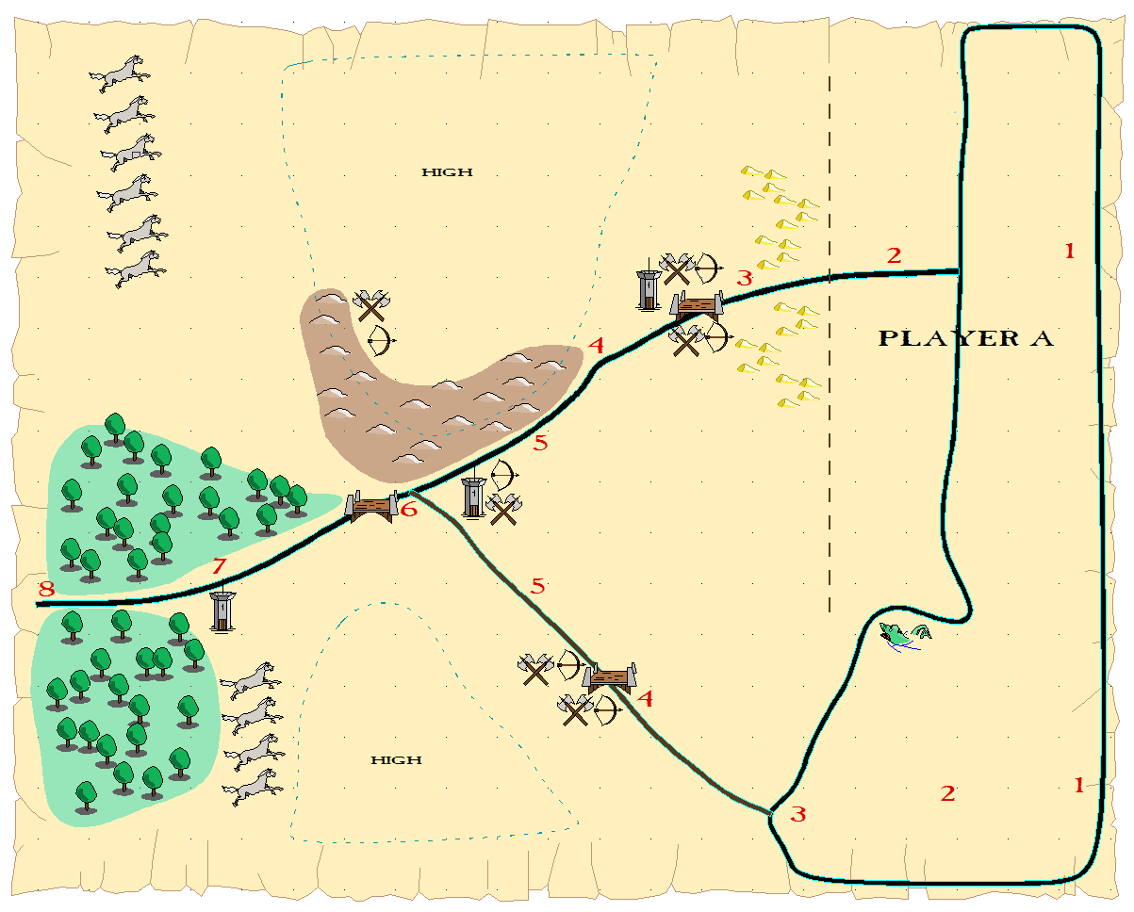
The attacker (that means you) gets a standard 2000 point Warmaster army. The defending Bretonnians have only 1700 points (they are missing three units) because they have three guard towers and a defended position.

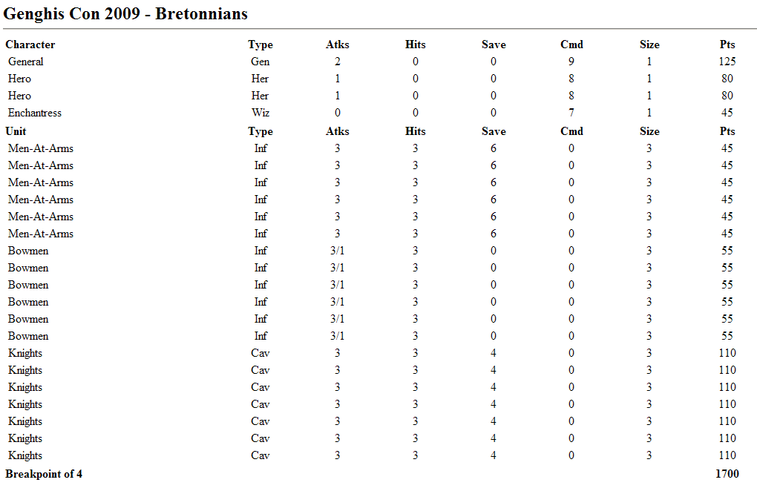
Scenario Two: Prison Break

The snaking Sirendell River winds back and forth upon itself several times in the lowlands of the Reaches. There, four prisons are located, each holding a unit of your army captured while scouting the area several weeks ago. The enemy army has been spotted, but you might have enough time to rescue your comrades. In this scenario, the attacker (that means you) moves second.

OBJECTIVES
- Kill your opponent – this is war, after all.
- Destroy the prison walls, releasing your captive units.

Additional Tournament Points | Condition
100 points | Destroy a prison.

MECHANICS
- SET UP: At the beginning of the game, set aside four of your units (no heroes) in the designated areas as being held in prison A, B, C, and D. Once a prison is destroyed, replace the prison model with the appropriate captive unit. NOTE: You may instantaneously form the unit up with an existing brigade.
- PRISONS: Each of the four prisons contains reinforcements for your side. However, they also contain fortified Empire canon installations. Bummer. To destroy the prison walls and the cannon, you must eliminate all enemy troops within 4” and bring one unit into contact with the prison base.
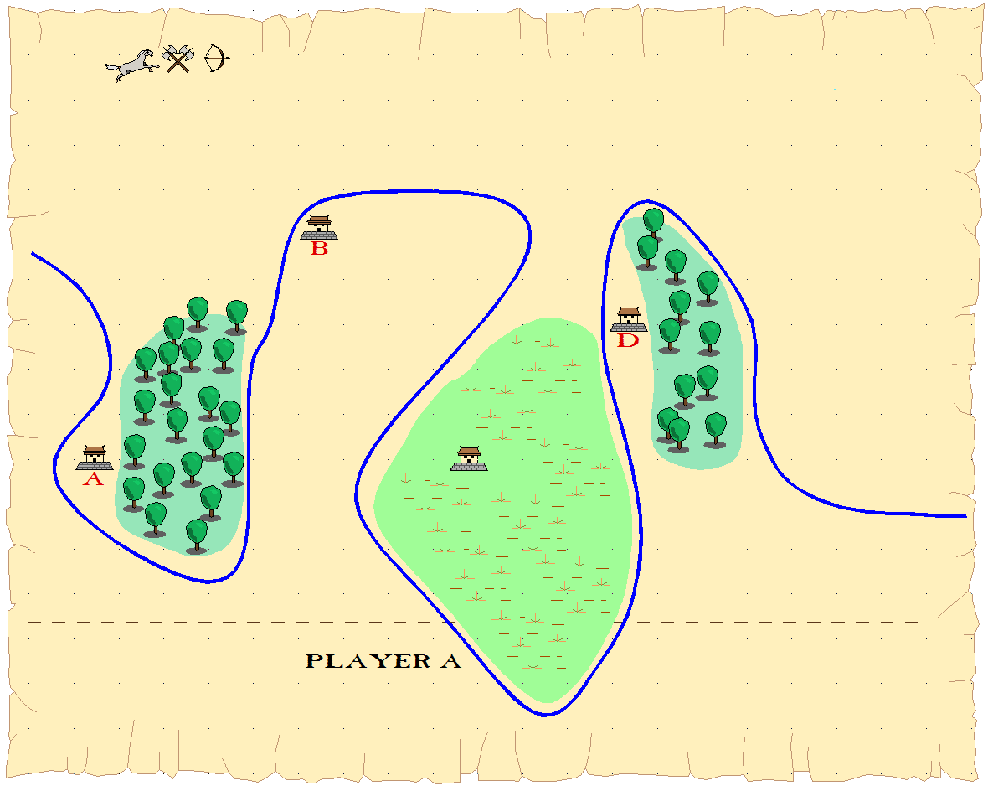
Scenario Three: Disruption

In this scenario, your army stumbles upon an Elvish supply train, taking food and supplies to their allies. The area is heavily forested, and you fear that the elves might simply fade into the woods unless you can strike quickly. In this scenario, the attacker (that means you) moves second.

OBJECTIVES
- Kill your opponent – this is war, after all.
- Destroy the three Elvish supply wagons.
- Keep the Elves from getting units off the far edge of the map.

Additional Tournament Points | Condition
-50 points | Each elf unit that gets off the far edge of the board with ½ or more of its stands intact.
100 points | Each supply wagon destroyed.

MECHANICS
- GUARD TOWERS: Supply Wagons can be destroyed by eliminating all enemy units within 4” and bringing one unit into contact with the wagon base. Supply wagons move at 20cm – they are elves, after all.
Scenario Four: Siege

In this scenario, your army reaches the Dwarven Stronghold and must defeat the entrenched stunties. In order to do this, you must scale the battlements of the fortress and knock on the front door. You do get a trebuchet to help you, however. In this scenario, the attacker (that means you) moves first.

OBJECTIVES
- Kill your opponent – this is war, after all.
- Knock on the front door.

Additional Tournament Points | Condition
500 points | Knock on the front door.

MECHANICS
- You may place your trebuchet anywhere in your deployment zone. Once placed, it cannot be moved.
- The gorge is impassable by all troops (except fliers).

