Warmaster “Gauntlet” Tournament

Think you are a Warmaster Champion? Consider the gauntlet thrown down. Come join us for a new, exciting tournament format.

On one side of the table, we have four seasoned Warmaster veterans (Chris, Brian, Bruce and Jeff), each armed with a standard army and a diabolical scenario to challenge your skills.

On the other side of the table, you and your teammate will have to decide how to best divide up these four challenges. Each of you will play two one-on-one games running the gauntlet of the four scenarios, scoring points based on your success or failure. Your team’s score will be compared to all other challengers at the Con. The team with the best overall score will be crowned Warmaster champion.

You need a standard 2000 point Warmaster army (no variants), some dice and lots of luck. Scenario descriptions will be available just prior to the Con – just drop me an email – cmatney@dragonsford.com. Loaner armies are available with prior arrangements as well. NOTE: If you don’t have a teammate in mind, no worries. Just sign up for a time slot, and we will get you paired up.

General Rules

- You must use the same army and army list for both rounds. Please bring a printed copy of your army list for your opponent with you to the Con.
- Each game is limited to 1 hour 45 minutes. This gives us 15 minutes to calculate scores and reset the tables.
- If an army breaks, the game ends immediately. There is no running up additional victory points by mopping up unmanned towers, prisons, carts and the like.

Scoring

All scenarios will use the standard Warmaster tournament scoring system as shown below. IMPORTANT NOTE: These points will be augmented by additional scenario-specific points. Each two-person team will be facing all four scenarios. Some of the scenarios have been designed to be more difficult than others, so victory in all four matches is not necessarily needed to win the tournament.

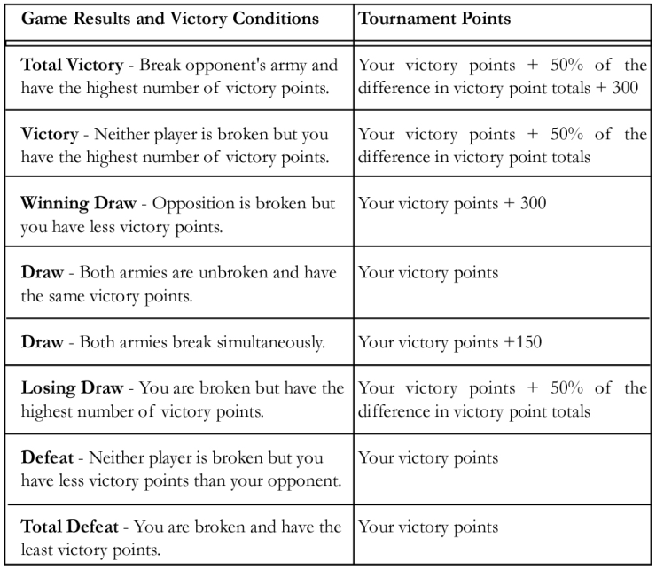
Scenario One: Invasion

In this scenario, your army starts on the shores of the Great Sea. In order to supply your invasion force, you must get supplies up the Sirendell River while defeating the first line of defense – those pesky Bretonnians and their crusading knights. In this scenario, the attacker (that means you) moves first.

OBJECTIVES
- Kill your opponent – this is war, after all.
- Defend your boat as it moves up the river.
- Take out defensive towers along the way.
- Get units off the far edge of the map.

Additional Tournament Points | Condition
50 points | Each unit (excluding fliers and characters) that gets off the far edge of the board with ½ or more of its stands intact. Up to a maximum of 250 points (5 units).
100 points | Each tower destroyed.
450 points | Safely escorting your ship off the map

MECHANICS
- BOAT MOVEMENT: Your boat moves up river following the layout on the map. You can either choose a northern or southern fork of the river. Boats carry supplies, but no troops. The boats can’t fire and can be attacked only as described below. Boats move at the end of each full turn. Boat movement is mandatory. At the end of the seventh turn, the boat leaves the map.
- GUARD TOWERS: Each of the three guard towers contains a single large ballista designed to sink boats coming up the river. The eastern tower can shoot at a boat in position 3 (north fork). The center tower can shoot at a boat in position 4. The western tower can shoot at a boat in positions 5 and 6. The towers cannot shoot at troops. A roll of a 4+ indicates a ballista hit and damages a boat. Towers can be destroyed by eliminating all enemy units within 10cm and bringing one unit into contact with the tower base. Boats take 4 hits to be destroyed. Towers do block line of sight.
- BRIDGES: The rivers are stop-and-go for infantry only. All other units must use a bridge. In addition, the Bretonnian player gets a single shot at a boat if they have at least one unit (with at least two stands) of archers within 10cm the bridge. This occurs at position 2 (north fork), position 3 (south fork) and position 4. Again, a roll of a 4+ indicates a hit against a boat. The rule about shooting at the nearest target is ignored in this situation, and the unit of archers designated as getting the shot cannot shoot at other targets. Bridges do not block line of sight.
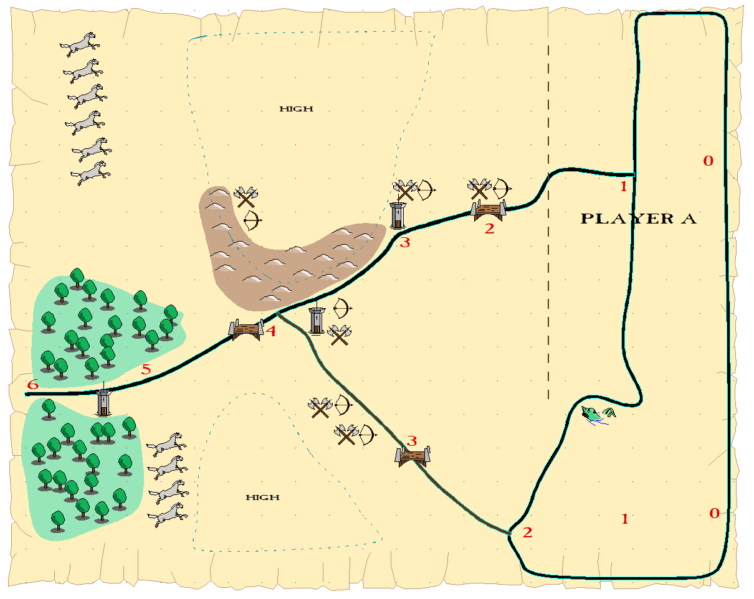
The attacker (that means you) gets a standard 2000 point Warmaster army. The defending Bretonnians has an army of only 1700 points because they have three guard towers and a defended position.

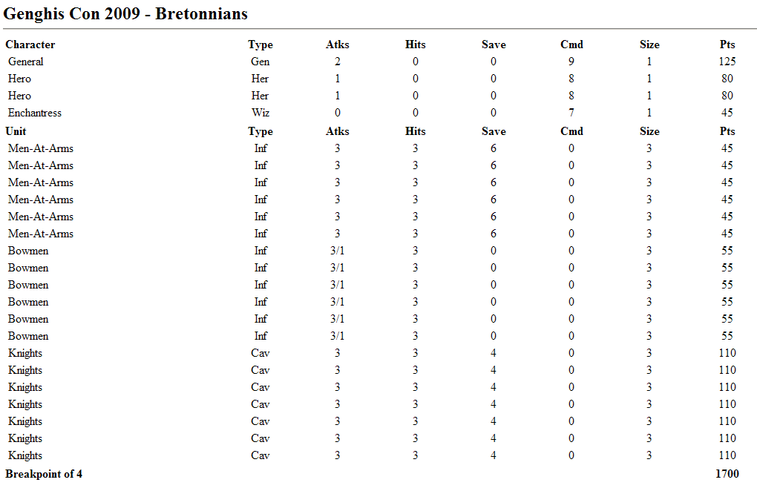
Scenario Two: Breakout

The snaking Sirendell River winds back and forth upon itself several times in the lowlands of the Reaches. There, four prisons are located. In these prisons are monstrous units, potential allies in your battle against the forces of good. The enemy army has been spotted, but you might have enough time to rescue the monsters and unleash their fury. In this scenario, the attacker (that means you) moves second.

OBJECTIVES
- Kill your opponent – this is war, after all.
- Destroy the prison walls, releasing the captive units.

Additional Tournament Points | Condition
50 points | First prison destroyed.
100 points | Second prison destroyed.
200 points | Third prison destroyed.
300 points | Fourth prison destroyed.

MECHANICS
- RIVERS: On this map, the Sirendell River is wide and slow. All units can stop-and-go at the river’s edge as long as one stand has its front edge along the riverbank before crossing. You may stand and fight in the river without penalty, but you may not redeploy or evade over the river. Shooting drive backs into the river cause confusion.
- SWAMP: The swamp cannot be crossed except by infantry. Movement is half rate, but line of sight is unaffected.
- PRISONS: Each of the four prisons contains reinforcements for your side – monstrous allies. However, they also contain fortified Empire cannon installations. Bummer. The cannons have 360 degree facing, can shoot in any direction (no flanking), and can see over the forest. They must shoot at the closest enemy unit, of course.
- MONSTERS IN CHAINS: The monsters inside the prison cannot do anything until they are released. Once a prison is destroyed, replace the prison model with the appropriate captive unit. At this point, they become another unit in your army and can be commanded in the normal way. They are allowed to redeploy on the turn they are released. However, they cannot be brigaded with your forces. NOTE: Adding a monster might increase your army’s breakpoint, but they also count against your point totals if killed.
- DESTROYING CANNONS AND PRISONS: Cannons can be destroyed in the usual way – shooting, spells or melee. The cannon are fortified enemy units following all the standard Warmaster rules. Once the cannon are destroyed, bringing a single unit (except fliers and heroes) into contact with prison base destroys it. NOTE: Nearby enemy troops do not need to be eliminated in order to destroy the prison.
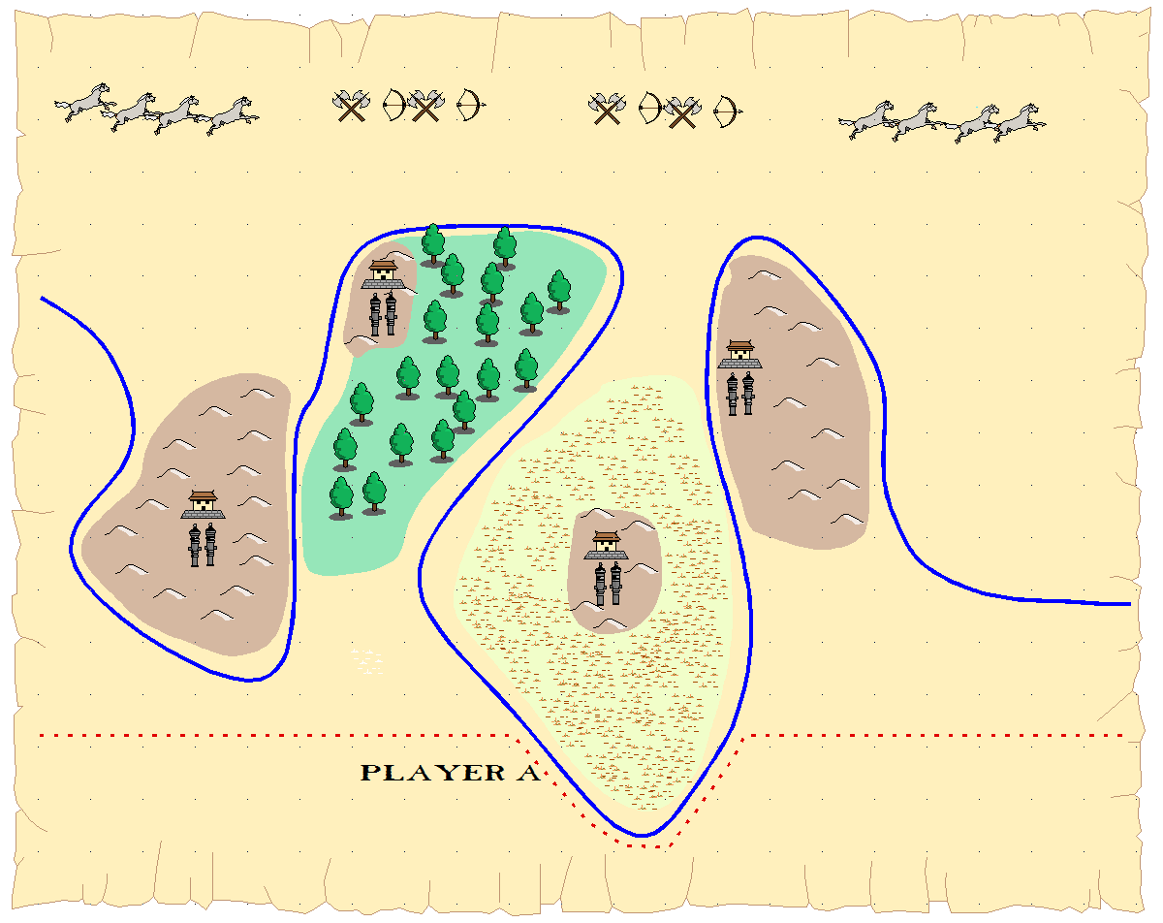
Both sides get a standard 2000 point Warmaster army.

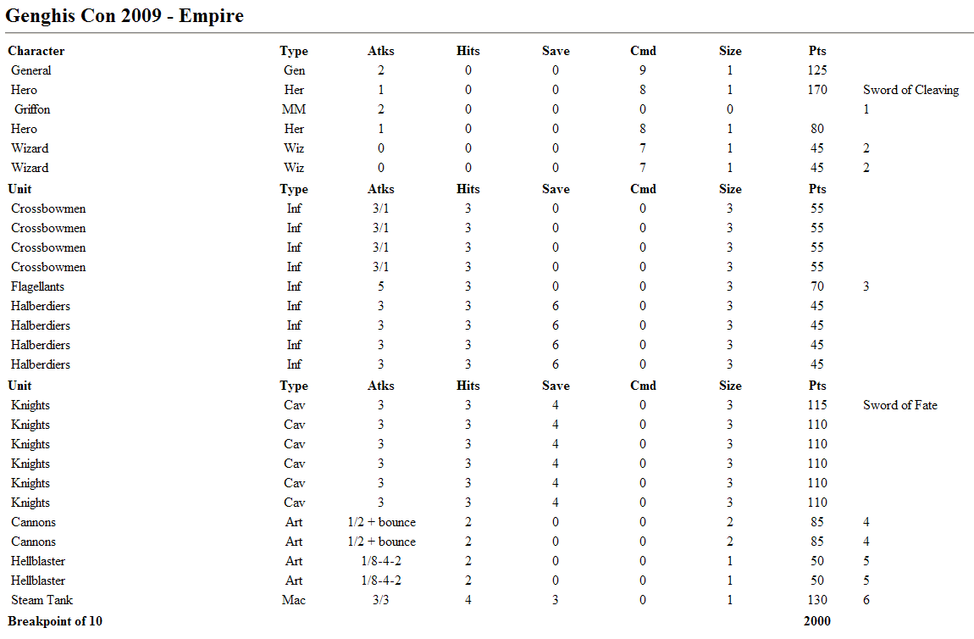
Scenario Three: Disruption

In this scenario, your army stumbles upon an Elvish supply train, taking food and supplies to their allies. The area is heavily forested, and you fear that the elves might simply fade into the woods unless you can strike quickly. In this scenario, the attacker (that means you) moves second.

OBJECTIVES
- Kill your opponent – this is war, after all.
- Destroy the three Elvish supply wagons.
- Keep the Elves from getting units off the far edge of the map.

Additional Tournament Points | Condition
-50 points | Each elf unit that gets off the far edge of the board with ½ or more of its stands intact. Up to 250 points (5 units).
-200 points | Each supply wagon that gets off the far edge of the board.
100 points | First supply wagon destroyed.
200 points | Second supply wagon destroyed.
300 points | Third supply wagon destroyed.

MECHANICS
- SUPPLY WAGONS: Supply Wagons can be destroyed by eliminating bringing one unit into contact with the wagon base. Units attempting to destroy a supply wagon do so in the main combat phase (after shooting) and may not undertake any other action during the turn. Supply wagons move 30cm along the road, 20cm in the open, and 10cm in the forest – they are elves, after all.
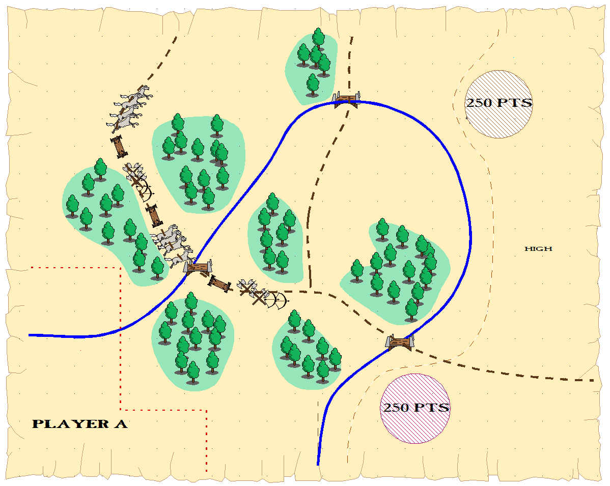
Both sides get a standard 2000 point Warmaster army.

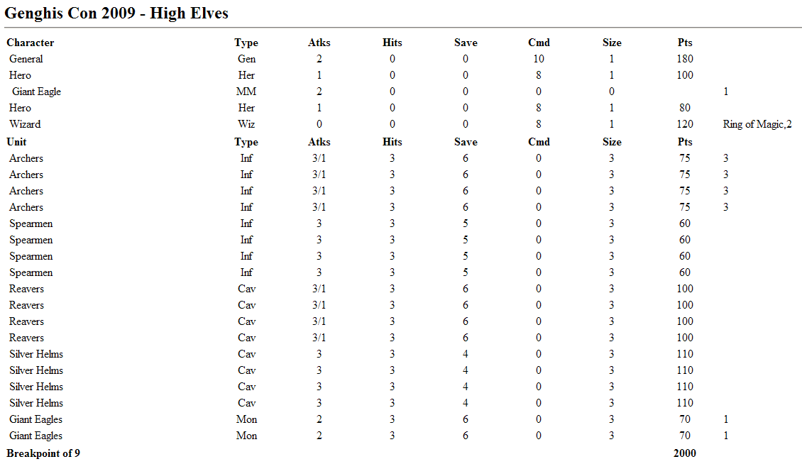
Scenario Four: Siege

In this scenario, your army reaches the Dwarven Stronghold and must defeat the entrenched stunties. The stronghold contains three massive wooden doors. For each door that you open, you score bonus points. The Dragon Door hold prisoner an angry blue dragon. Open that door and get a dragon to help you out. If two of the three doors are opened, the Dwarven Stronghold is overrun and his army is considered broken. BTW, you do get a trebuchet to help you. In this scenario, the attacker (that means you) moves first.

OBJECTIVES
- Kill your opponent – this is war, after all.
- Knock on two of the three doors to win the siege. Opening the Dragon Door lets the dragon out.

Additional Tournament Points | Condition
200 points | Opening the first door.
400 points | Opening the second door.

MECHANICS
- You may place your trebuchet anywhere in your deployment zones. Once placed, it cannot be moved.
- The Dragon Door may be opened by getting any unit (except fliers and characters) in contact with the door. Once opened, the player gets a dragon (see stats below) to aid them in their conquest of the dwarves.
- The gorge is impassable by all troops (except fliers).
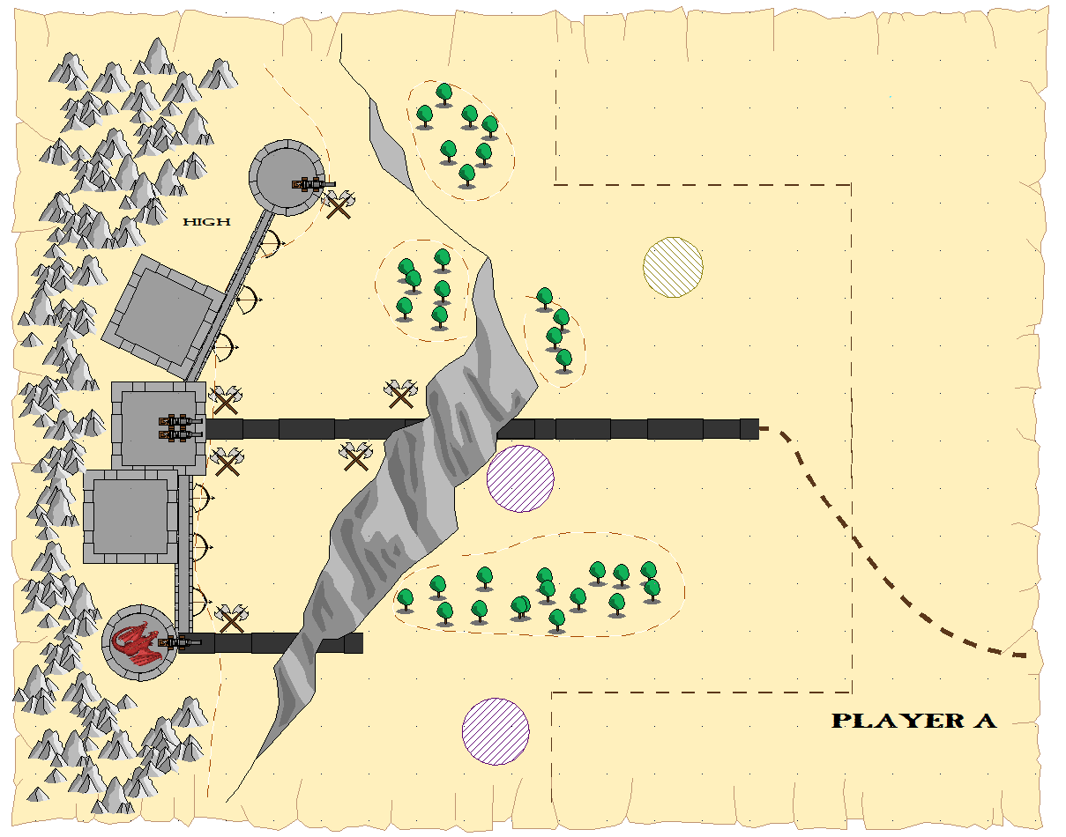
The attacker (that means you) gets a standard 2000 point Warmaster army. The defending Dwarves have only 1715 points because they have a defended position.

